**Handout on Classification**

This tutorial is a continuation of Tutorial 1 on Raster Analysis and Tutorial 2 on vector analysis. We assume you are familiar with images, bands, spectral curves and vector layers. First, open the image in QGIS and open the SCP dock. In case the dock is not visible, go to View>Panels>SCP Dock. Create a training input.

In the above, there are options of MC ID and C ID. These stand for Macro-class ID and Class ID. Macro-classes can include the superset of the classes. For e.g. vegetation is a macro-class, cropland, forest, grasslands, pastures etc are the classes. Similar water body is a macro-class and inland water body, river, sea are the classes. In our example, we are going to use only three macro-classes. MC 1: Vegetation, MC2: Barren and MC3: Water. We can now create training ROIs (Regions of interest) for the same. Training ROIs are samples which are fed to a supervised classifier to train it to recognise a class. We can create ROIs by using the ROI polygon creator tool: 

Left click over the image to add the vertices of the polygon and right click to close the polygon. This creates a temporary polygon.

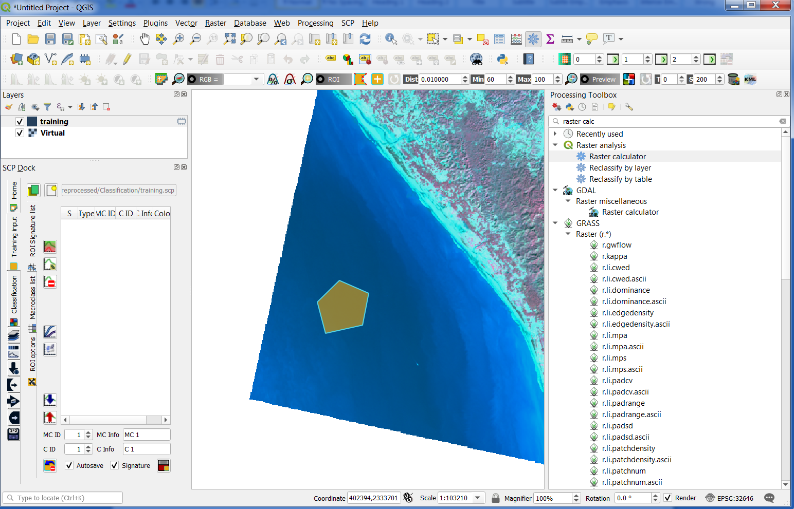

The temporary polygon can be saved as a training polygon by clicking on this button: You can double click on the colour and change the colour associated with the class too.

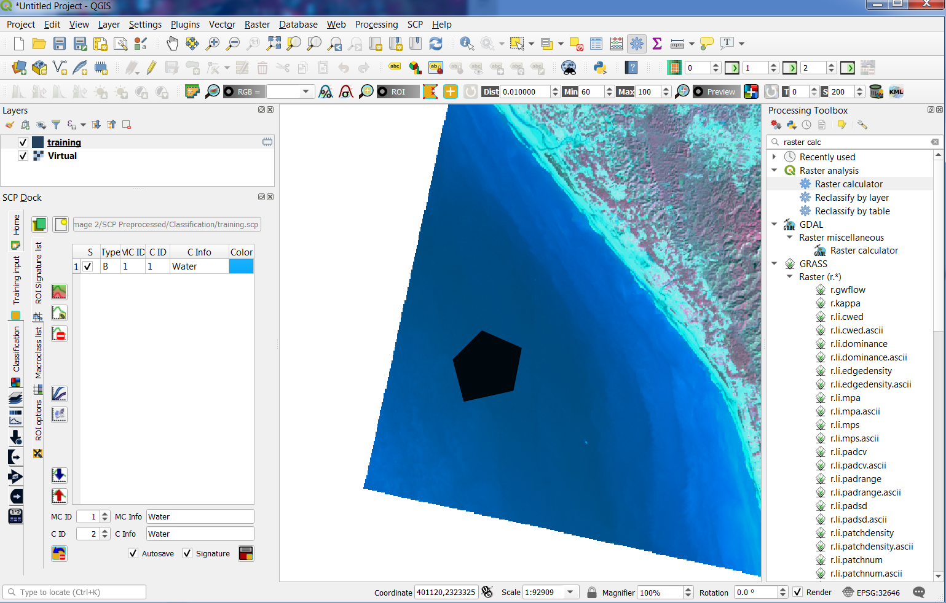

The class ID you will notice has incremented to 2. We can change the MC ID as well and create a training polygon for vegetation and barren in the same way. We can now visualize the spectral profile for each of the classes. Select two or more rows in the list of classes and macroclasses. Then click the spectral profile tool button: . The following window pops up:

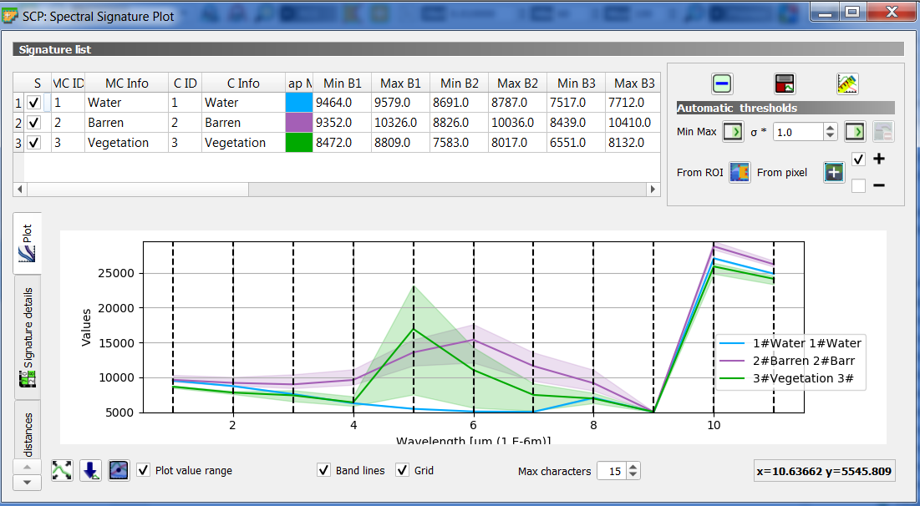

In the plot we can see the line of each signature (with the colour defined in the ROI Signature list), and the minimum and maximum of each band (i.e. the semi-transparent area) for the training ROIs selected. The larger is the semi-transparent area of a signature, the higher is the standard deviation, and therefore the less the homogeneity of pixels that composed that signature.

We can also see the heterogeneity of the pixels through the scatter plot. For this, after selecting the classes, select the scatter plot button: . The resulting pop up will show the scatter plot for some band combination. Homogentiy of the pixels is given by more concentrated points rather than oblate plots. the Bands can be modified in this window.

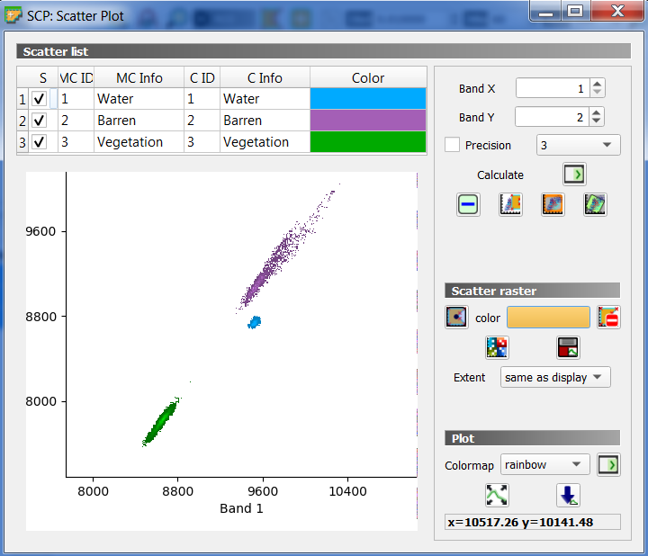

Next, click on the classification dock and choose whether you would like to classify on the basis of MC ID or CID. In our case, both are the same. Select your classification algorithm. We will select Spectral Angle Mapper in this attempt. Now click run and save your file.

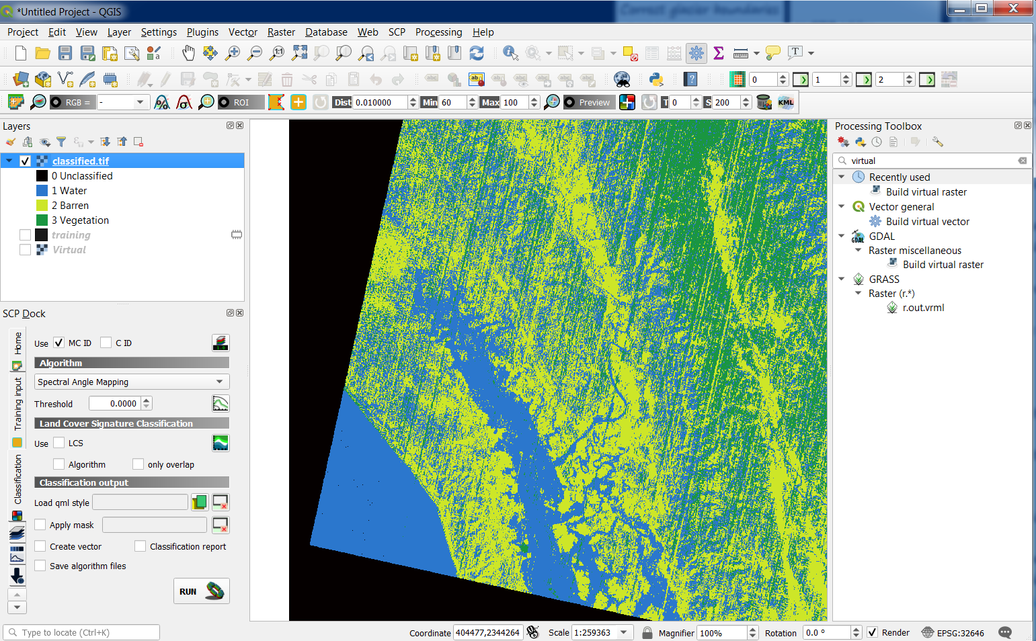

You now have your classified output. In order to check the accuracy of your file, create a vector layer with an attribute called MC ID. Select polygons from each class and ensure that you put in the right MC ID for each. Now, from the Home tab of SCP Dock, click the post-processing button: . In the resulting pop up, select Accuracy Assessment and set the classified image and reference image can be set as the testingROI. Ensure that you put in the MC_ID field created for this purpose. Click Run.

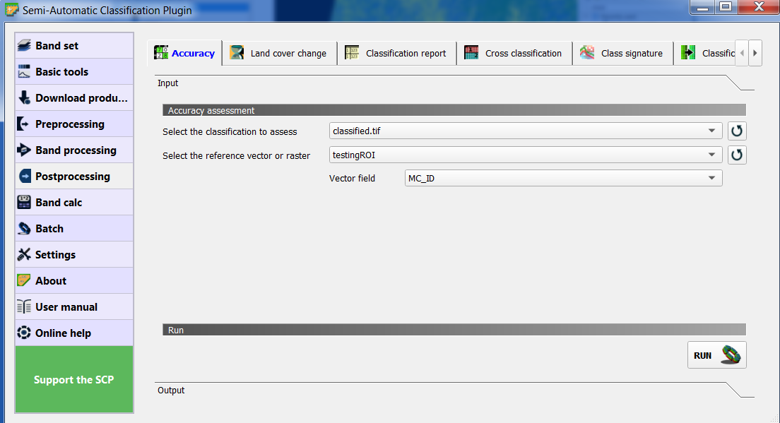

The accuracy report is generated. In case the results are not satisfactory, the training ROIs can be tweaked and the procedure can be attempted again.



